9.33: The angular velocity of the rear wheel is 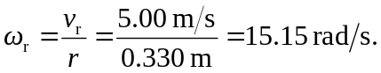
The angular velocity of the front wheel is 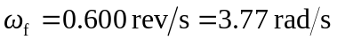
Points on the chain all move at the same speed, so 